**Meeting Scheduler**

**Design Document**

**Version 1.0**



**Group Id: S22024B990**

**Supervisor Name: Dr. Sarfraz Ahmad Awan**

**Revision History**

|  |  |  |  |
| --- | --- | --- | --- |
| **Date (dd/mm/yyyy)** | **Version** | **Description** | **Author** |
| 15/08/2022 | 1.0 | The meeting scheduler web application will address the challenges of manual meeting process. The goal of this application is to develop an automated meeting scheduler which could coordinate among the members digitally.    This document includes different diagrams, test cases and interface designs of application. | BC190200421 |
|  |  |  |  |
|  |  |  |  |
|  |  |  |  |

**Table of Contents**

1. Introduction of Design Document
2. Entity Relationship Diagram (ERD)
3. Sequence Diagrams
4. Architecture Design Diagram
5. Class Diagram
6. Database Design
7. Interface Design
8. Test Cases
9. Introduction of Design Document

The software design document is a detailed plan for developing the meeting scheduler web application. It is a map that helps to keep you on track from start of a project to the last lines of code. This document breaks down nearly every aspect of project. This document transforms the requirements as described in the SRS document into a form implementable using a programming language. By creating a design document, we can establish exact expectations for the project before we start coding. To create this document, we have to think through our entire system architecture before writing any code. This allows us to avoid probable complications and plan around them. It is a centralized document that outlines features, dependencies, other useful information. It is an overview of what needs to be built and how. It is created to describe all parts of application and how they will operate.

This document consists of:

* **ERD:**

An entity relationship diagram (ERD) is a graphical representation that depicts relationships among entities (such as people, objects, places, concepts or events). ER models are mostly developed for designing relational databases in terms of concept visualization and in terms of physical database design. An entity is shown with its name and its attributes listed with it. A relationship between two entities signifies that two entities are associated with each other. Cardinality defines the possible number of occurrences in one entity which is associated with number of occurrences in another. The three common cardinality relationships are one-to-one, one-two-many, and many-to-many.

* **Sequence Diagrams:**

Sequence diagrams are interaction diagrams that detail how operations are carried out. They capture the interaction between objects in context of a collaboration. These diagrams are used to understand requirements for a new system. Sequence diagrams are sometimes known as event diagrams or event scenarios. They are time focused and they show the order of interaction visually by using the vertical axis of diagram to represent time what messages are sent and when. These diagrams capture the interaction that takes place in a collaboration that realizes a use case. It captures high-level interaction between user of application and application.

* **Architecture Diagram:**

An architecture diagram is a visual representation that maps out physical implementation for components of application. It shows the general structure of application and the associations, limitations and boundaries between each other. It is used to abstract the overall outline of application. It is an important tool as it provides an overall view of physical deployment of application and its evolution roadmap. It consists of three layers, presentation layer, business layer and data layer.

* **Class Diagram:**

A class diagram is a type of static structure diagram that describes the structure of a system by showing the system’s classes, their attributes, methods and relationships among objects. The class has its name, attributes, and methods that the class may use. Class diagram helps to better understand the general overview of schematics of application.

* **Database Design Diagram:**

Database diagrams graphically shows the structure of database and relations between database objects. To create relations between database objects, we consider using primary keys and foreign keys. Database objects contains their attributes. Cardinality defines the possible number of occurrences in one object which is associated with number of occurrences in another.

* **User Interfaces:**

User Interface (UI) design is the process designers use to build interfaces in software or computerized devices focusing on looks and style. Designers aim to create interfaces which users find easy to use and pleasurable. UI design refers to graphical user interfaces of application. UI design focuses on what users might need to do and ensuring that interface has elements that are easy to access, understand, and use to facilitate those actions.

* **Test Cases:**

Test cases are used to define how to test the application. A test case is a singular set of actions or instructions for a tester to perform that validates a specific aspect of application functionality. If test fails, the result might be an application defect that developer can sort. A test case contains a set of data, pre-conditions, post-conditions, and expected results developed for a particular test scenario in order to verify compliance against a specific document.

**Benefits:**

* Speed up implementation by providing a clear reference throughout.
* Reduce friction in code reviews by creating architectural alignment ahead of implementation.
* Provide answers to stakeholders, reducing distractions during implementation for busy engineers.
* Act as a reference once the system is up and running to help anyone understand the system.
* Especially useful to help onboard new team members.

**Purpose:**

* Requirements are well understood.
* Design document gives us complete overview of how product look like and better insight about product.
* New person can very easily understand the project through documentations and start working on it.
* Everything is well stated. It explains each and every feature of application.
* Helpful in understanding the role and contribution of each and every member.

1. Entity Relationship Diagram (ERD) (To be developed using Microsoft Visio or any other drawing software of your choice)

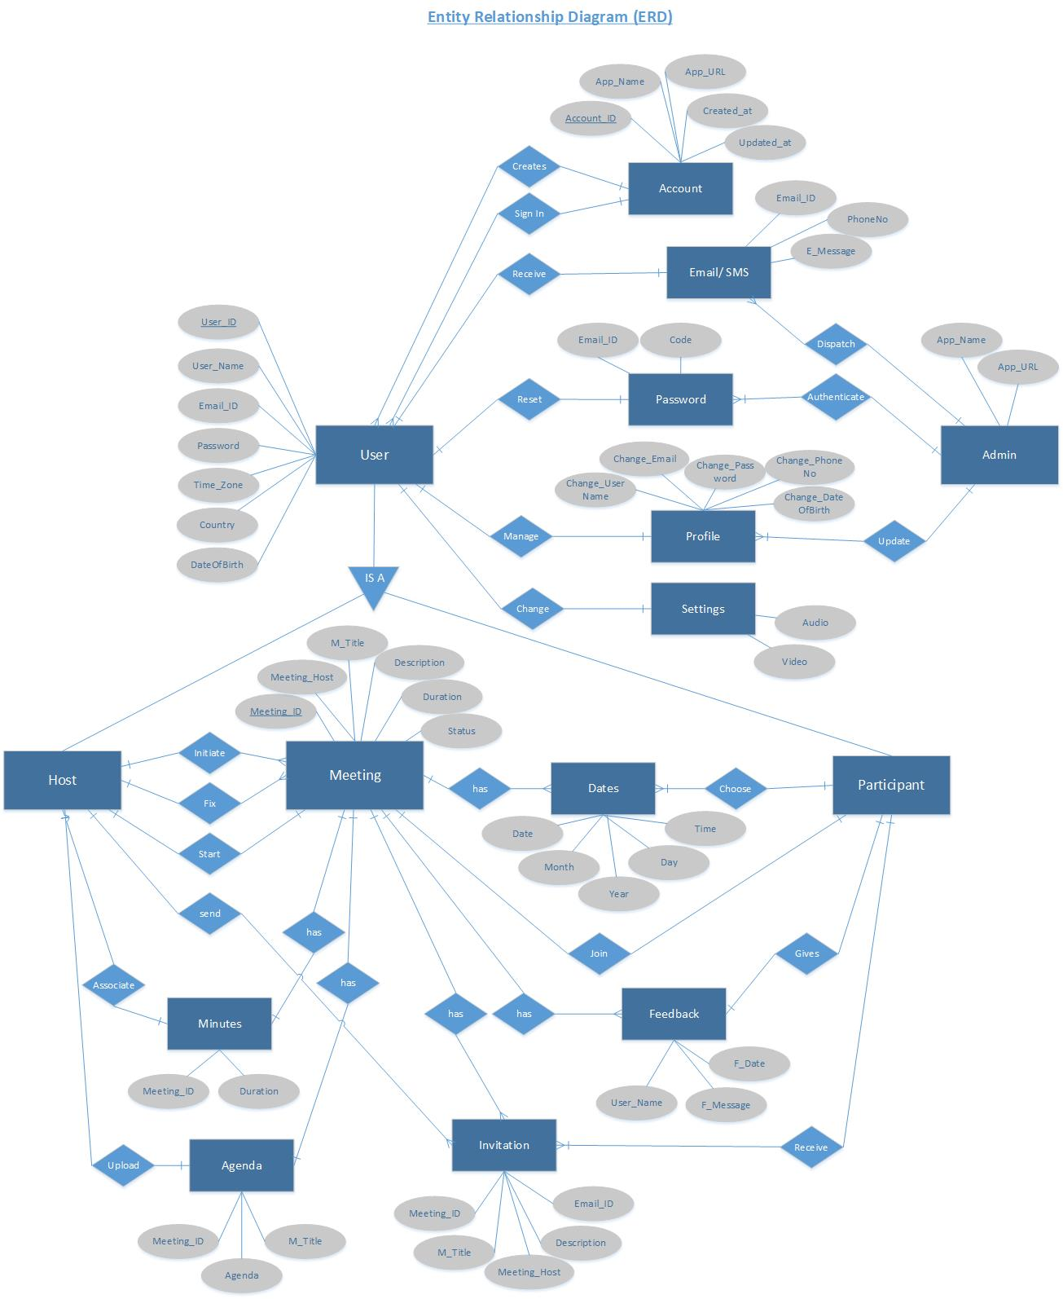

**Entity Relationship Diagram (ERD)**

1. Sequence Diagrams (To be developed using Rational Rose or any other drawing software of your choice)

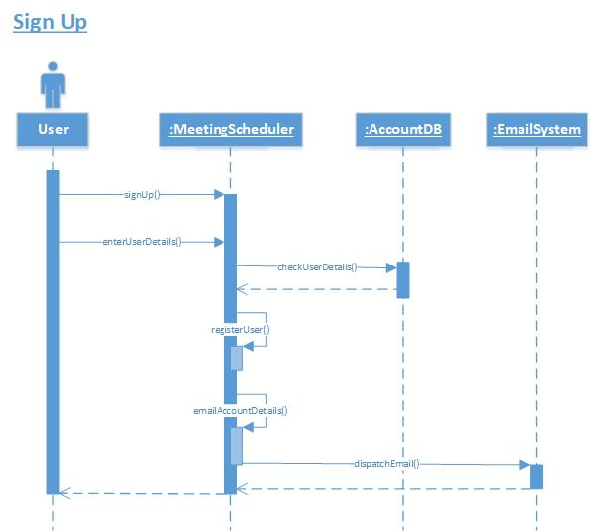

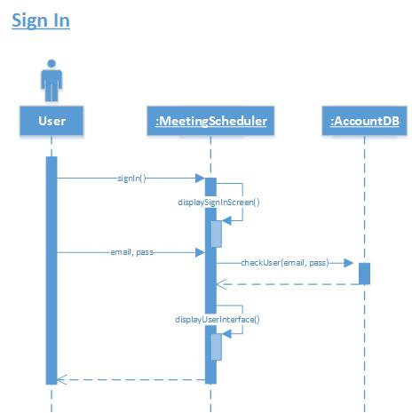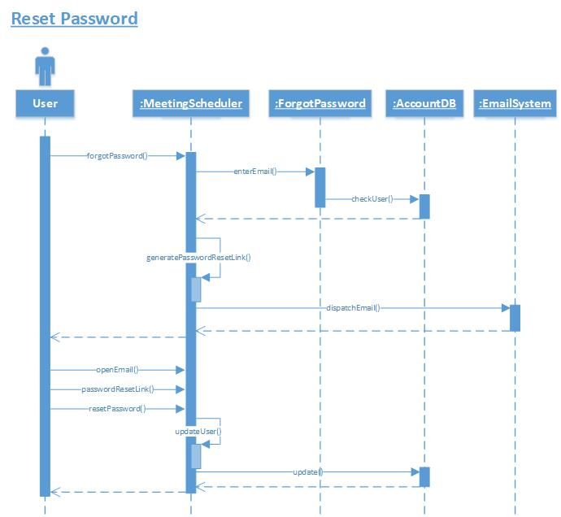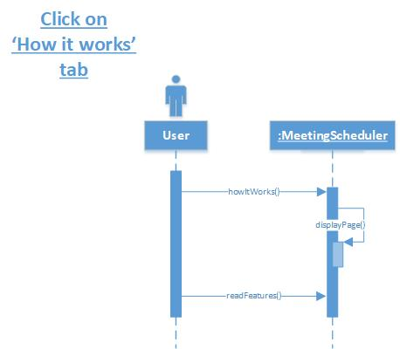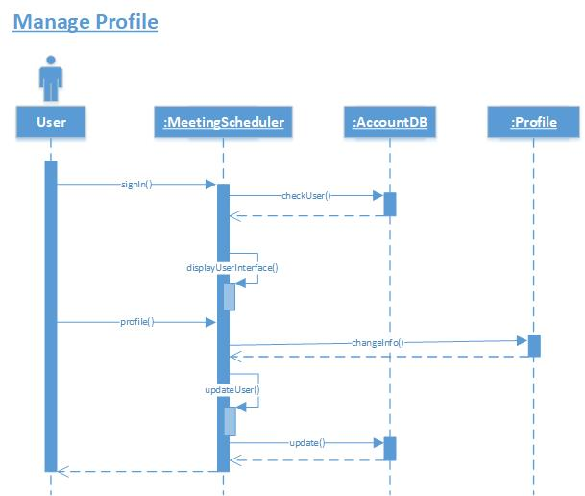

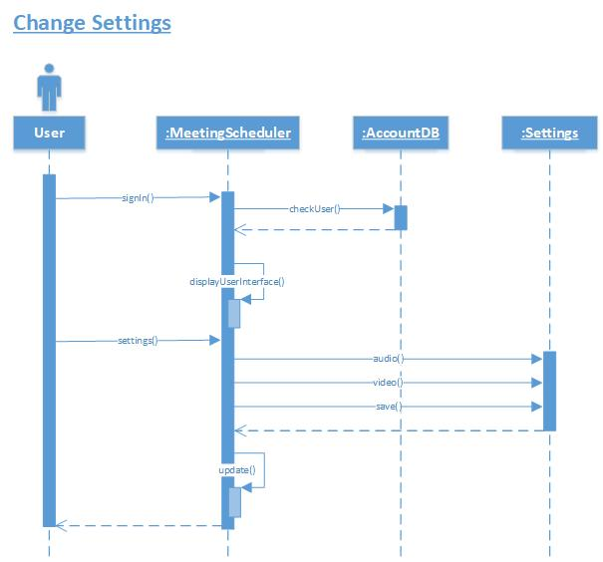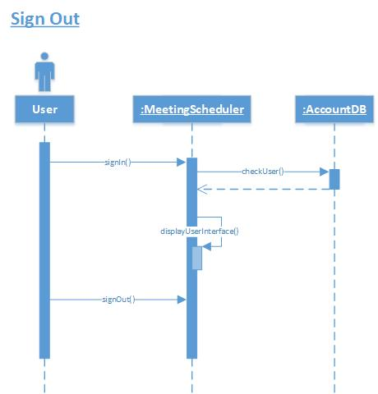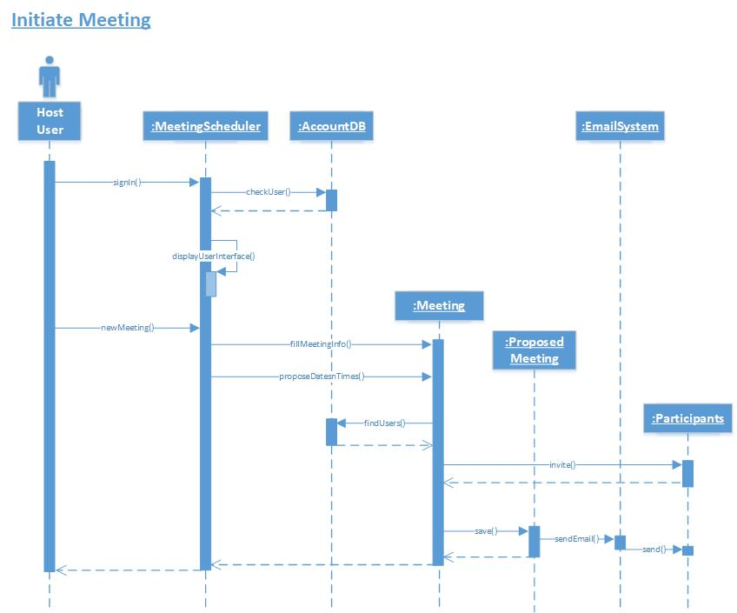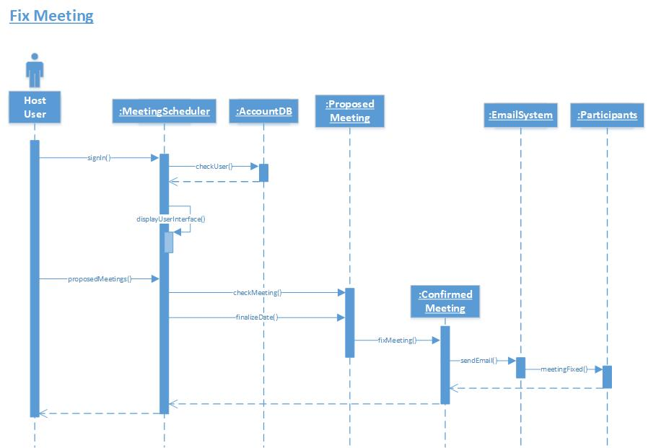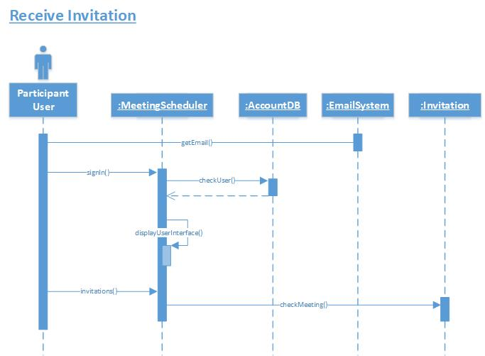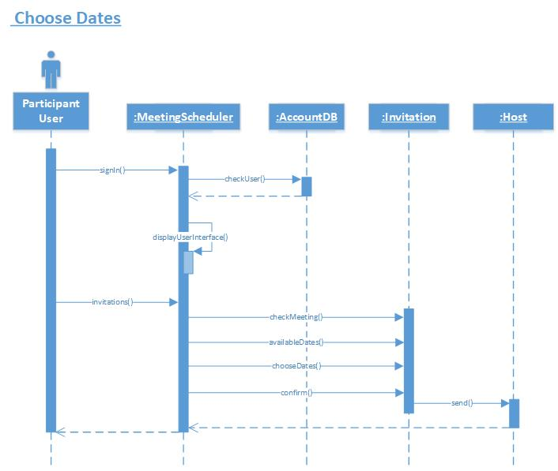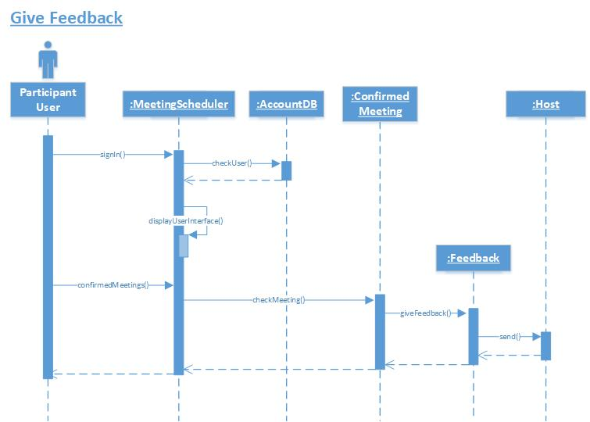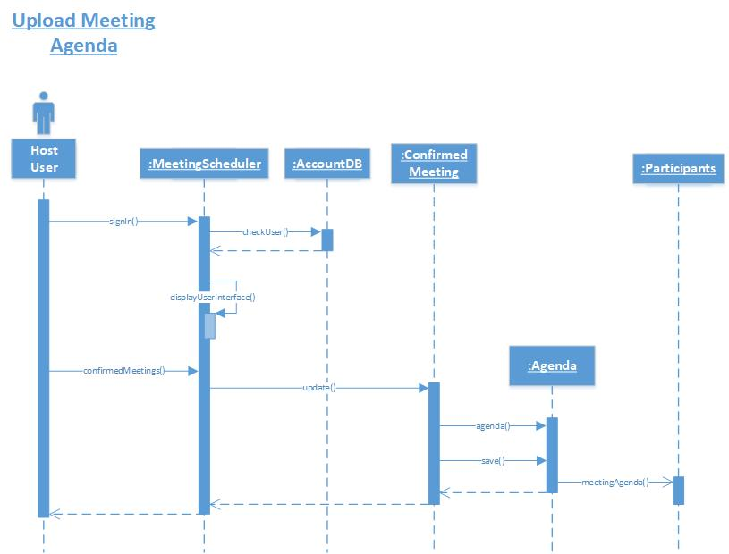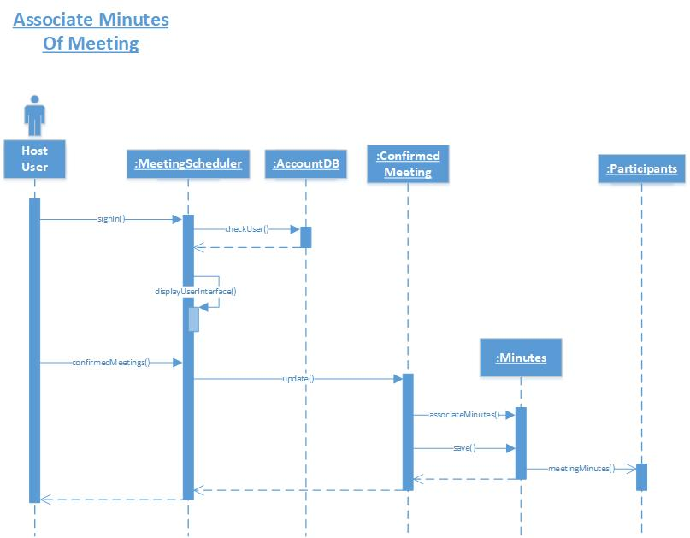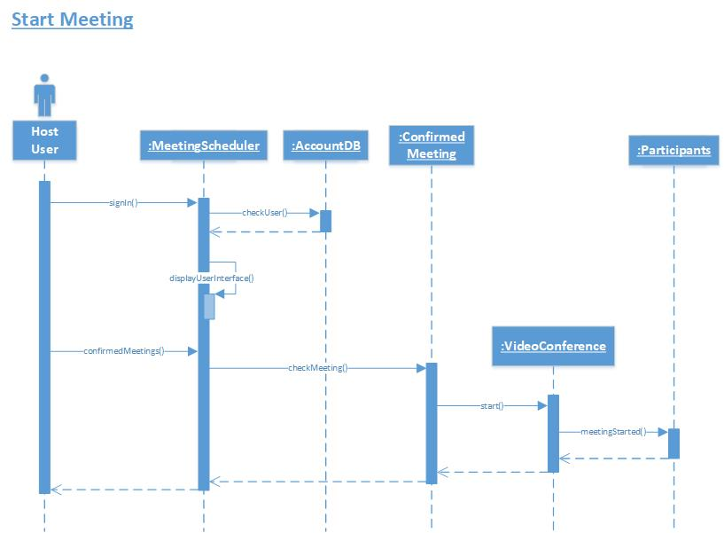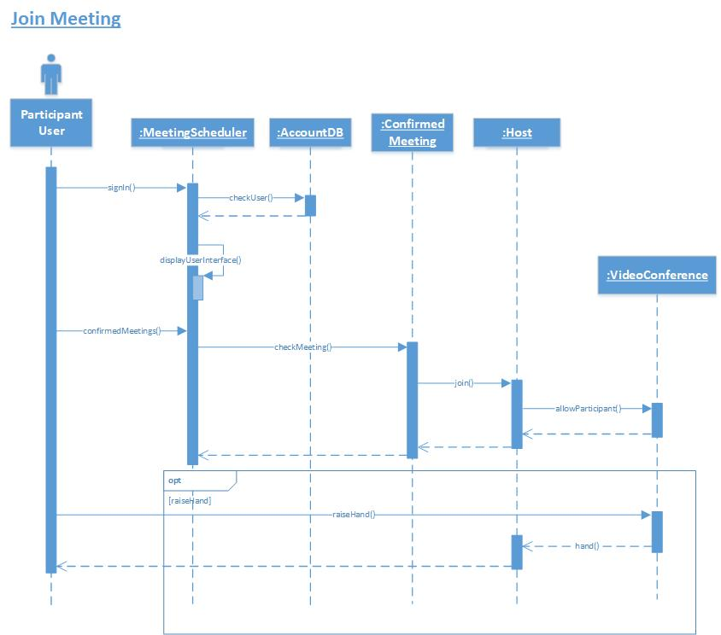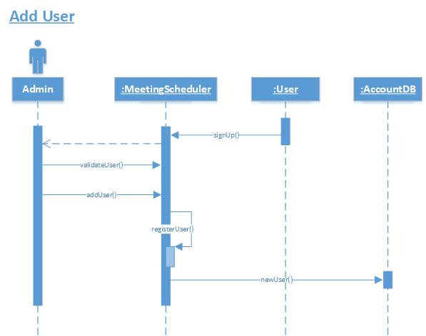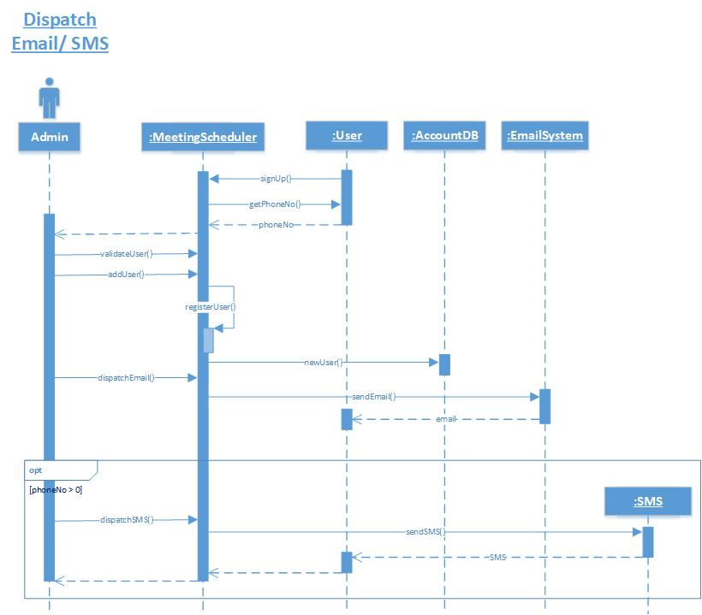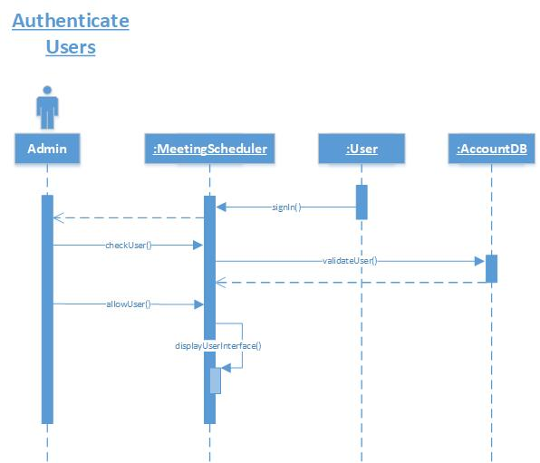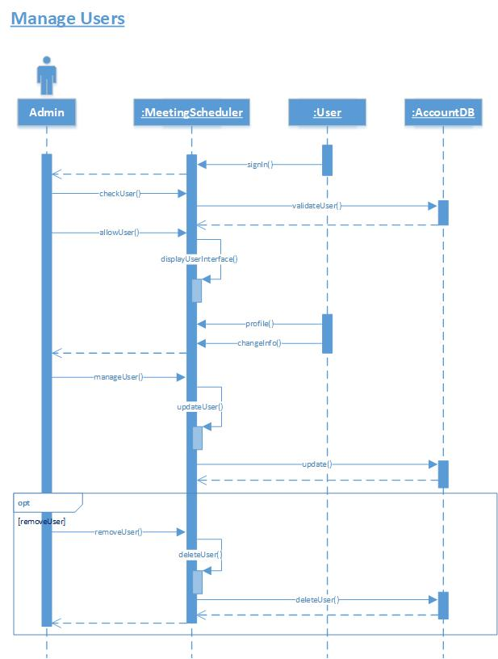

1. Architecture Design Diagram

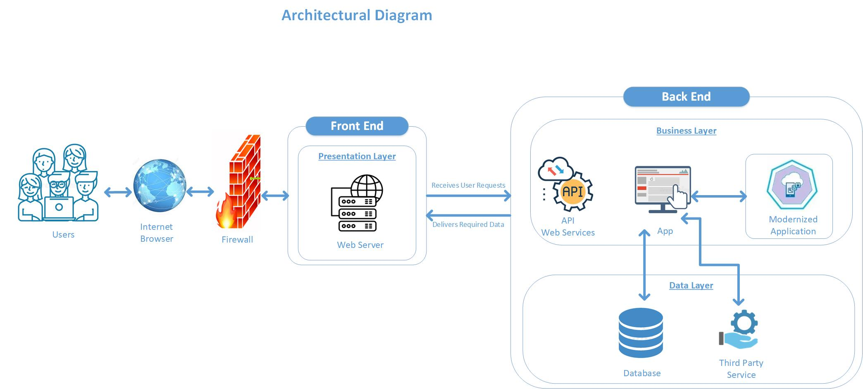

**Architecture Design Diagram**

1. Class Diagram

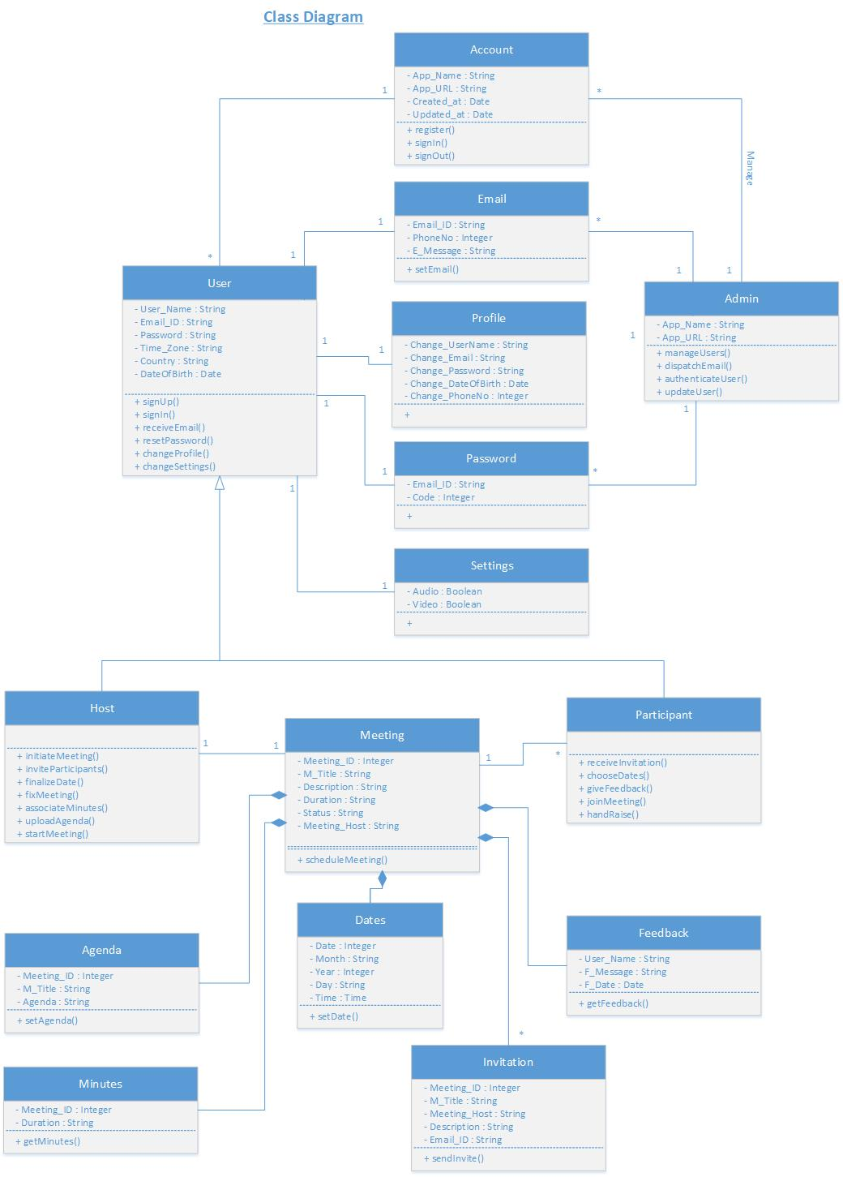

**Class Diagram**

1. Database Design

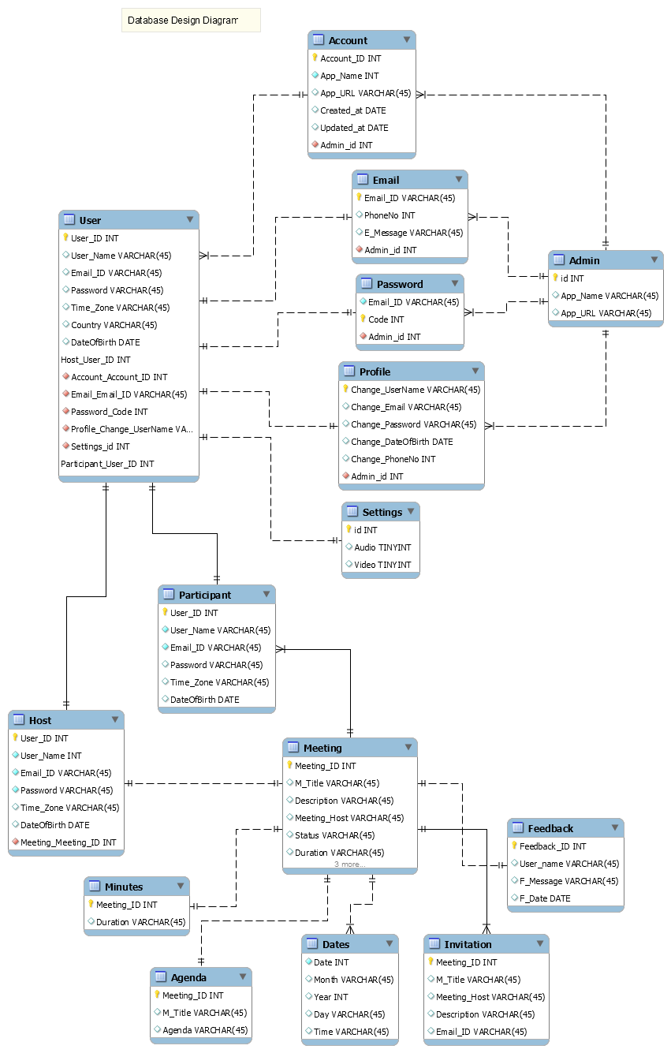

**Database Design Diagram**

1. Interface Design

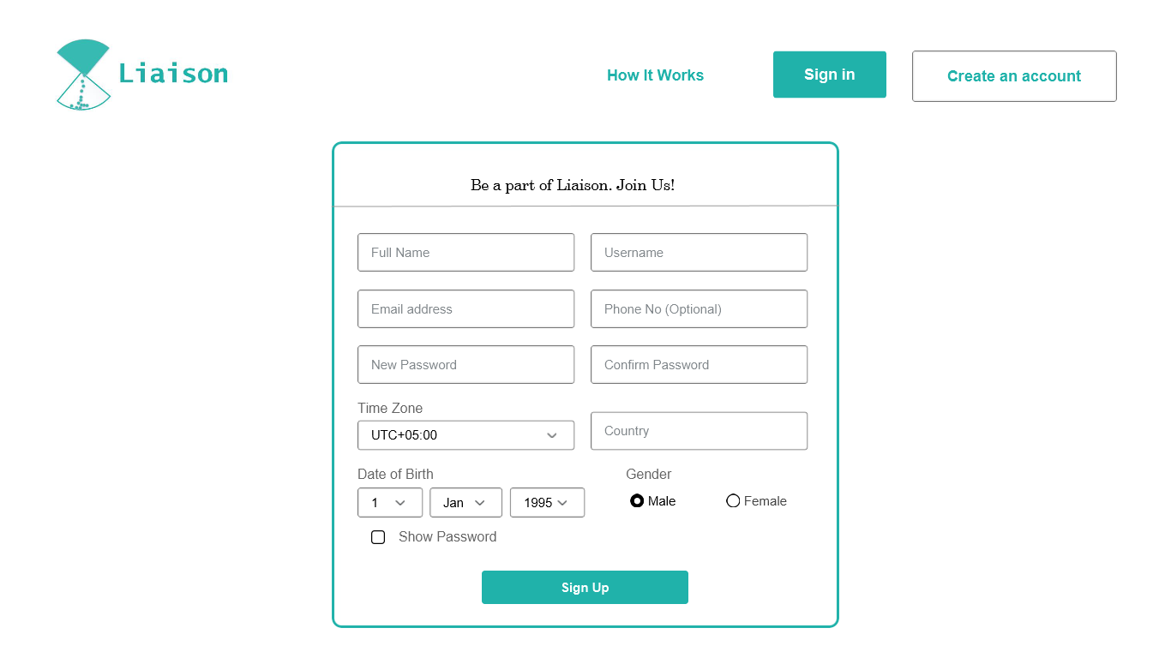

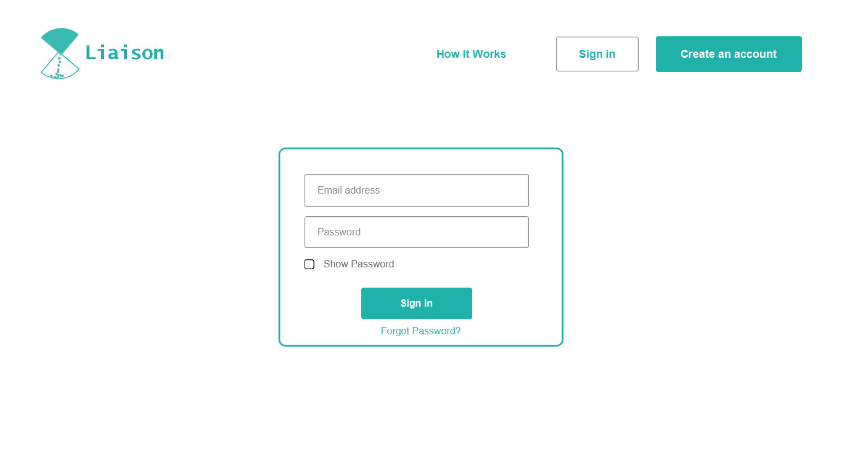

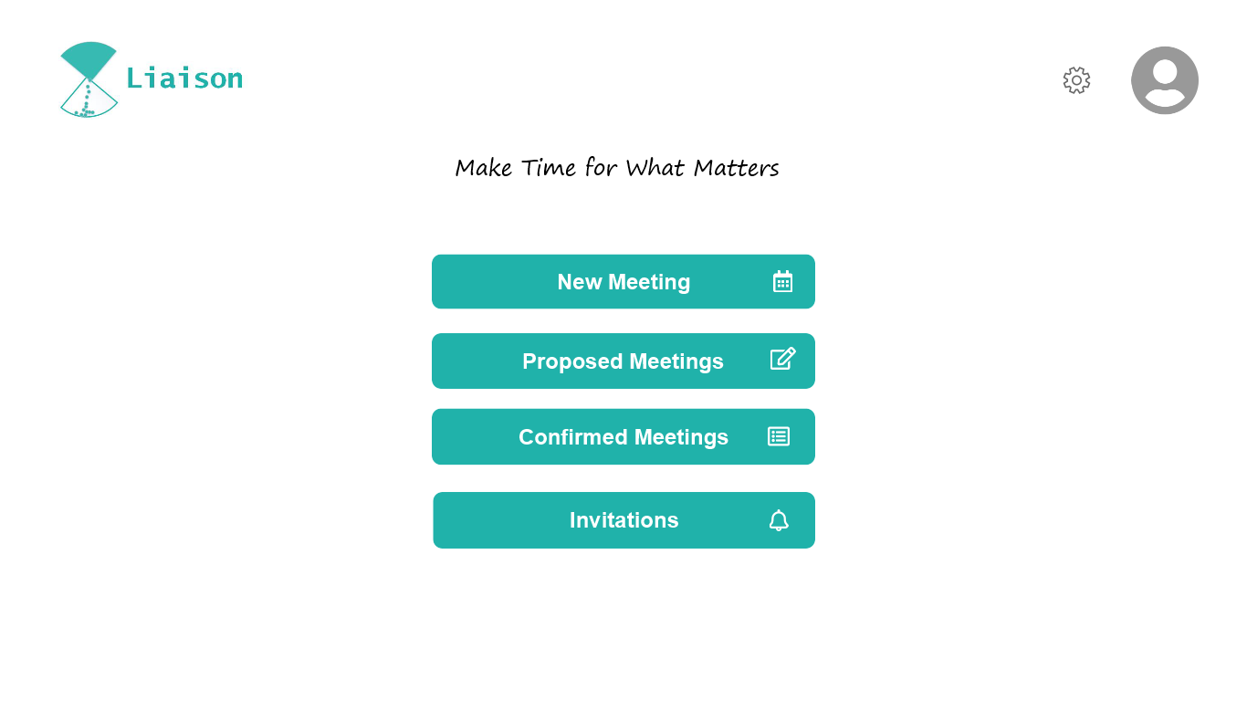

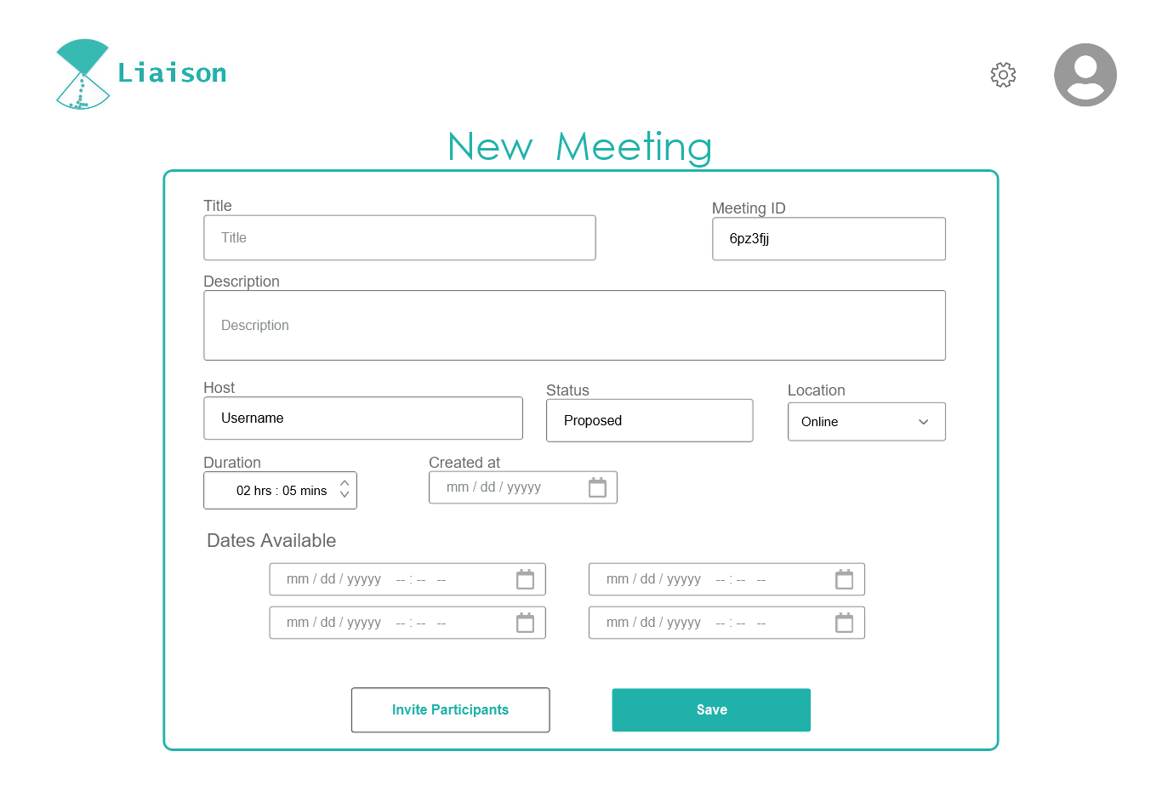

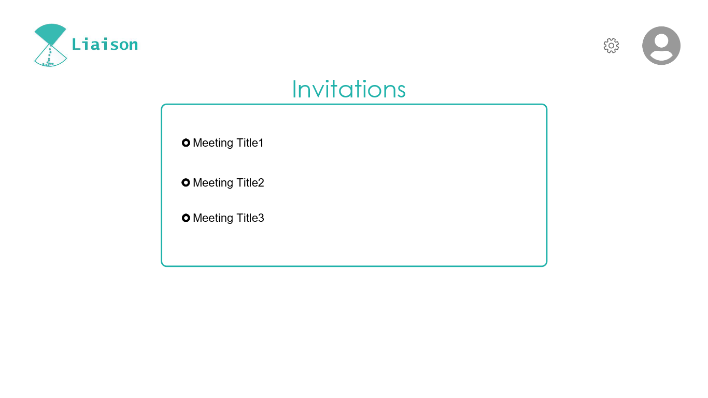

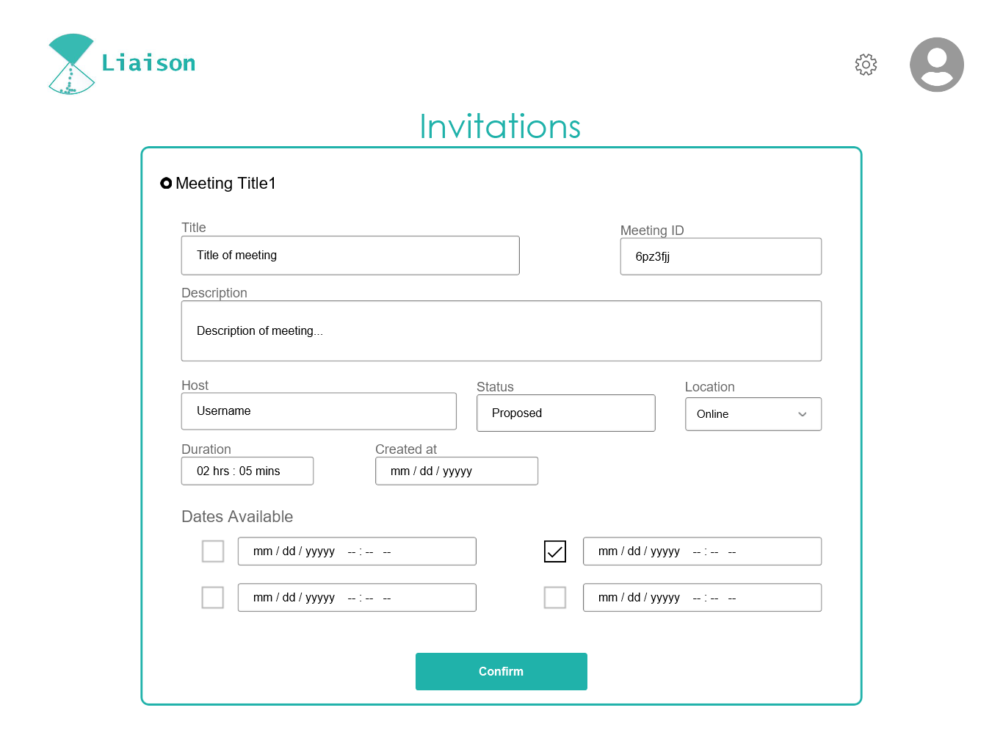

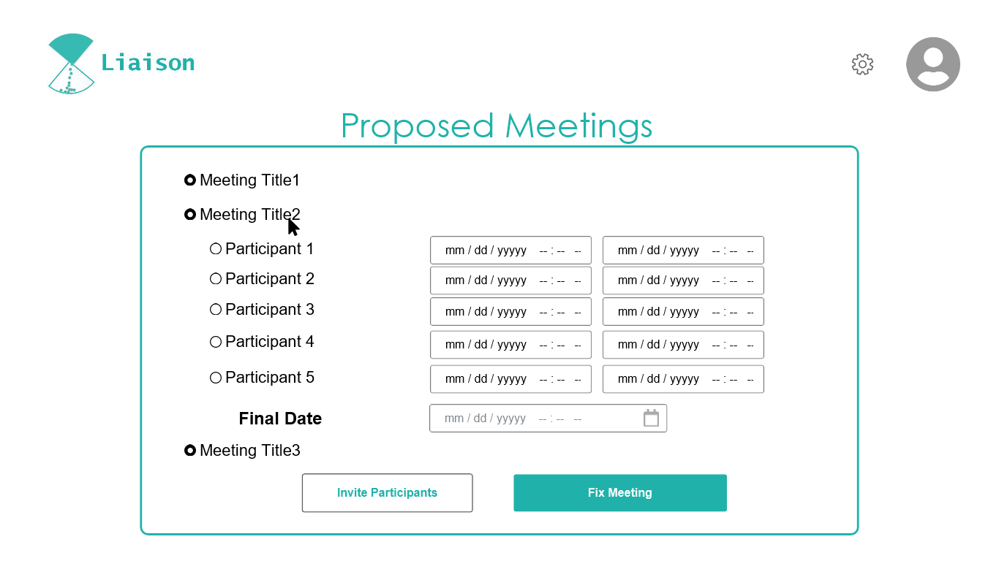

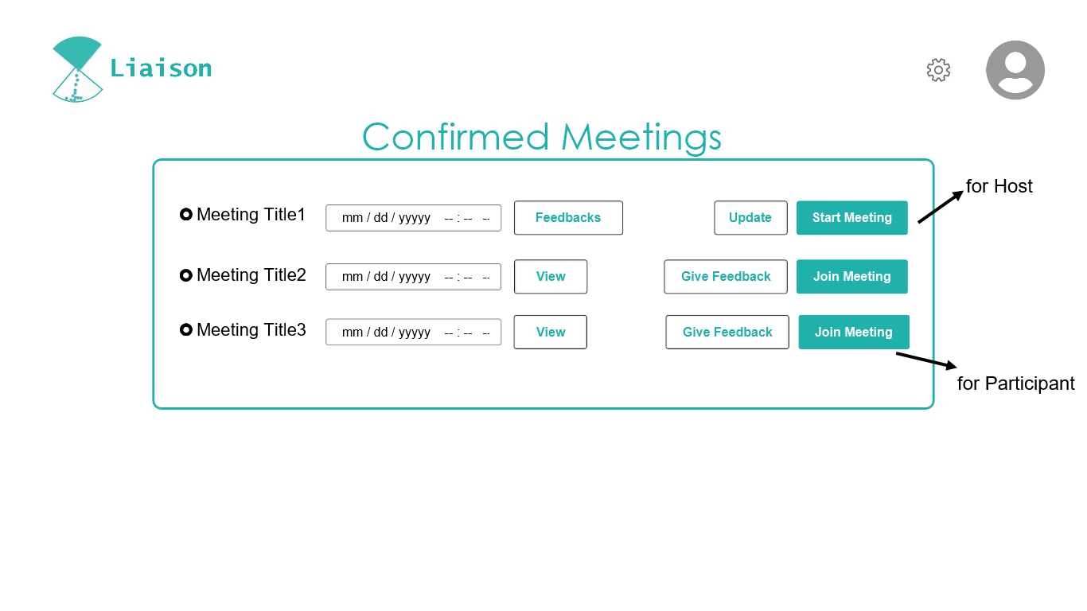

1. **Test Cases**

**Test Case Title:** Testing the ‘How it works’ tab mechanism of Meeting Scheduler Web-Application.

|  |  |  |  |  |  |  |  |  |
| --- | --- | --- | --- | --- | --- | --- | --- | --- |
| **TC ID** | **Use Case ID** | **Scenario ID** | **Test Steps** | **Expected Output** | **Pre-Condition** | **Post Condition** | **Pass/Fail Criteria** | **Tested By** |
| T1 | UC01 | 1-1 | 1. Go to web application. 2. Click ‘How it works’ tab. | User is redirected to ‘How it works’. | User must be on homepage of application. | User will be aware by use of application and its features. | Pass | Rutab Khanam |

**Test Case Title:** Testing the Sign-up mechanism of Meeting Scheduler Web-Application.

|  |  |  |  |  |  |  |  |  |
| --- | --- | --- | --- | --- | --- | --- | --- | --- |
| **TC ID** | **Use Case ID** | **Scenario ID** | **Test Steps** | **Expected Output** | **Pre-Condition** | **Post Condition** | **Pass/Fail Criteria** | **Tested By** |
| T2 | UC02 | 2-1 | 1. Go to web application. 2. Click ‘Create an account’ tab. 3. Fill sign-up form. 4. Click ‘Sign Up’ button. | Registration is successful. | User must have a valid email address. | A confirmation Email/ SMS will be received. | Pass | Rutab Khanam |
| T3 | UC02 | 2-2 | 1. Go to web application. 2. Click ‘Create an account’ tab. 3. Fill sign-up form. 4. Click ‘Sign Up’ button. | Please enter a valid email address. | User must have a valid email address. | Failed to Sign-up | Pass | Rutab Khanam |
| T4 | UC02 | 2-3 | 1. Go to web application. 2. Click ‘Create an account’ tab. 3. Fill sign-up form. 4. Click ‘Sign Up’ button. | You have already an account in application. Try with another email. | User must have a valid email address. | Failed to Sign-up | Pass | Rutab Khanam |

**Test Case Title:** Testing the Add User mechanism of Meeting Scheduler Web-Application.

|  |  |  |  |  |  |  |  |  |
| --- | --- | --- | --- | --- | --- | --- | --- | --- |
| **TC ID** | **Use Case ID** | **Scenario ID** | **Test Steps** | **Expected Output** | **Pre-Condition** | **Post Condition** | **Pass/Fail Criteria** | **Tested By** |
| T5 | UC03 | 3-1 | 1. User Sign-up. 2. Admin adds the user to the system. | User registered successfully. | User must have completed the sign-up process. | User is registered successfully. | Pass | Rutab Khanam |
| T6 | UC03 | 3-2 | 1. User Sign-up. 2. Admin adds the user to the system. | Try again with another email address. | User must have completed the sign-up process. | User is already registered. | Pass | Rutab Khanam |

**Test Case Title:** Testing the Dispatch Email/ SMS mechanism of Meeting Scheduler Web-Application.

|  |  |  |  |  |  |  |  |  |
| --- | --- | --- | --- | --- | --- | --- | --- | --- |
| **TC ID** | **Use Case ID** | **Scenario ID** | **Test Steps** | **Expected Output** | **Pre-Condition** | **Post Condition** | **Pass/Fail Criteria** | **Tested By** |
| T7 | UC04 | 4-1 | 1. User Sign-up. 2. A confirmation Email/ SMS will be dispatched. | Email sent; account registered. | User must be registered successfully. | A confirmation Email/ SMS will be received. | Pass | Rutab Khanam |
| T8 | UC04 | 4-2 | 1. User Sign-up. 2. A confirmation Email/ SMS will be dispatched. | Invalid email/ Phone no. | User must be registered successfully. | No Email | Pass | Rutab Khanam |

**Test Case Title:** Testing the Reset Password mechanism of Meeting Scheduler Web-Application.

|  |  |  |  |  |  |  |  |  |
| --- | --- | --- | --- | --- | --- | --- | --- | --- |
| **TC ID** | **Use Case ID** | **Scenario ID** | **Test Steps** | **Expected Output** | **Pre-Condition** | **Post Condition** | **Pass/Fail Criteria** | **Tested By** |
| T9 | UC05 | 5-1 | 1. Go to web application. 2. Open Sign-in page. 3. Click ‘forgot password’ link. 4. Enter email address. 5. Reset password via email. | Password is reset. | User must be authorized. | User can sign-in with new password. | Pass | Rutab Khanam |
| T10 | UC05 | 5-2 | 1. Go to web application. 2. Open Sign-in page. 3. Click ‘forgot password’ link. 4. Enter email address. | User not found | User must be authorized. | Password is not reset. | Pass | Rutab Khanam |

**Test Case Title:** Testing the Sign-in mechanism of Meeting Scheduler Web-Application.

|  |  |  |  |  |  |  |  |  |
| --- | --- | --- | --- | --- | --- | --- | --- | --- |
| **TC ID** | **Use Case ID** | **Scenario ID** | **Test Steps** | **Expected Output** | **Pre-Condition** | **Post Condition** | **Pass/Fail Criteria** | **Tested By** |
| T11 | UC06 | 6-1 | 1. Go to web application. 2. Click ‘Sign-in’ tab. 3. Enter Email. 4. Enter Password. 5. Click ‘Sign In’ button. | Signed-In | User must be authorized | Appealing user interface is available to use. | Pass | Rutab Khanam |
| T12 | UC06 | 6-2 | 1. Go to web application. 2. Click ‘Sign-in’ tab. 3. Enter Email. 4. Enter Password. 5. Click ‘Sign In’ button. | Invalid Username/ Password | User must be authorized | Failed to Sign-In | Pass | Rutab Khanam |

**Test Case Title:** Testing the Authenticate Users mechanism of Meeting Scheduler Web-Application.

|  |  |  |  |  |  |  |  |  |
| --- | --- | --- | --- | --- | --- | --- | --- | --- |
| **TC ID** | **Use Case ID** | **Scenario ID** | **Test Steps** | **Expected Output** | **Pre-Condition** | **Post Condition** | **Pass/Fail Criteria** | **Tested By** |
| T13 | UC07 | 7-1 | 1. User Sign-in. 2. Admin match the user from database. 3. Allow/ Reject to sign-in. | Allow Sign-in | User data must be available in the system. | User have been signed in to the application. | Pass | Rutab Khanam |
| T14 | UC07 | 7-2 | 1. User Sign-in. 2. Admin match the user from database. 3. Allow/ Reject to sign-in. | User is not registered | User data must be available in the system. | Sign-in rejected | Pass | Rutab Khanam |

**Test Case Title:** Testing the Initiate Meeting mechanism of Meeting Scheduler Web-Application.

|  |  |  |  |  |  |  |  |  |
| --- | --- | --- | --- | --- | --- | --- | --- | --- |
| **TC ID** | **Use Case ID** | **Scenario ID** | **Test Steps** | **Expected Output** | **Pre-Condition** | **Post Condition** | **Pass/Fail Criteria** | **Tested By** |
| T15 | UC08 | 8-1 | 1. Sign-in 2. Click ‘New Meeting’. 3. Enter required details. 4. Propose Dates & Times. 5. Click ‘Invite Participants’ button to invite. 6. Click ‘Save’ button. | Meeting Initiated | User must be authorized. | The meeting invitation will be sent to all user participants. | Pass | Rutab Khanam |
| T16 | UC08 | 8-2 | 1. Sign-in 2. Click ‘New Meeting’. 3. Enter required details. 4. Propose Dates & Times. 5. Click ‘Invite Participants’ button to invite.   Click ‘Save’ button. | Please fill missing fields to proceed. | User must be authorized. | Meeting is not initiated. | Pass | Rutab Khanam |

**Test Case Title:** Testing the Propose Dates & Times mechanism of Meeting Scheduler Web-Application.

|  |  |  |  |  |  |  |  |  |
| --- | --- | --- | --- | --- | --- | --- | --- | --- |
| **TC ID** | **Use Case ID** | **Scenario ID** | **Test Steps** | **Expected Output** | **Pre-Condition** | **Post Condition** | **Pass/Fail Criteria** | **Tested By** |
| T17 | UC09 | 9-1 | 1. Initiate Meeting. 2. Propose different Dates & Times. 3. Click ‘Save’ button. | Available different dates of meeting. | User must initiate a new meeting. | Participants will be able to choose dates of meeting. | Pass | Rutab Khanam |

**Test Case Title:** Testing the Invite Participants mechanism of Meeting Scheduler Web-Application.

|  |  |  |  |  |  |  |  |  |
| --- | --- | --- | --- | --- | --- | --- | --- | --- |
| **TC ID** | **Use Case ID** | **Scenario ID** | **Test Steps** | **Expected Output** | **Pre-Condition** | **Post Condition** | **Pass/Fail Criteria** | **Tested By** |
| T18 | UC10 | 10-1 | 1. Initiate Meeting. 2. Propose different Dates & Times. 3. Click ‘Invite Participants’ button. 4. Select participants. 5. Click ‘Invite’ button. | Invitation Sent | User must have initiated a meeting. | An invitation will be sent to all selected participants. | Pass | Rutab Khanam |

**Test Case Title:** Testing the Receive Invitation mechanism of Meeting Scheduler Web-Application.

|  |  |  |  |  |  |  |  |  |
| --- | --- | --- | --- | --- | --- | --- | --- | --- |
| **TC ID** | **Use Case ID** | **Scenario ID** | **Test Steps** | **Expected Output** | **Pre-Condition** | **Post Condition** | **Pass/Fail Criteria** | **Tested By** |
| T19 | UC11 | 11-1 | 1. Sign-in 2. Click ‘Invitations’. | Invitation Received | Participant must be authorized user of application. | You have a meeting invitation. | Pass | Rutab Khanam |

**Test Case Title:** Testing the Choose Dates mechanism of Meeting Scheduler Web-Application.

|  |  |  |  |  |  |  |  |  |
| --- | --- | --- | --- | --- | --- | --- | --- | --- |
| **TC ID** | **Use Case ID** | **Scenario ID** | **Test Steps** | **Expected Output** | **Pre-Condition** | **Post Condition** | **Pass/Fail Criteria** | **Tested By** |
| T20 | UC12 | 12-1 | 1. Sign-in 2. Click ‘Invitations’. 3. Click ‘Meeting’. 4. Select possible dates. 5. Click ‘Confirm’ button. | Meeting Dates Selected | User should have an invitation. | Host can see the dates selected by the participant. | Pass | Rutab Khanam |
| T21 | UC12 | 12-2 | 1. Sign-in 2. Click ‘Invitations’. 3. Click ‘Meeting’. 4. Select possible dates. 5. Click ‘Confirm’ button. | Please select dates to confirm. | User should have an invitation. | Meeting dates not selected. | Pass | Rutab Khanam |

**Test Case Title:** Testing the Fix Meeting mechanism of Meeting Scheduler Web-Application.

|  |  |  |  |  |  |  |  |  |
| --- | --- | --- | --- | --- | --- | --- | --- | --- |
| **TC ID** | **Use Case ID** | **Scenario ID** | **Test Steps** | **Expected Output** | **Pre-Condition** | **Post Condition** | **Pass/Fail Criteria** | **Tested By** |
| T22 | UC13 | 13-1 | 1. Sign-in. 2. Click ‘Proposed Meetings’. 3. Click ‘Meeting’. 4. Select Final Date & Time. 5. Click ‘Fix Meeting’ button. | Meeting Fixed | Host user should receive the dates chosen by participants. | The specific meeting can be seen in confirmed meetings.  A notification/ email will be sent to all participants. | Pass | Rutab Khanam |
| T23 | UC13 | 13-2 | 1. Sign-in. 2. Click ‘Proposed Meetings’. 3. Click ‘Meeting’. 4. Select Final Date & Time. 5. Click ‘Fix Meeting’ button. | Please select date to fix meeting. | Host user should receive the dates chosen by participants. | Meeting not fixed. | Pass | Rutab Khanam |

**Test Case Title:** Testing the Give Feedback mechanism of Meeting Scheduler Web-Application.

|  |  |  |  |  |  |  |  |  |
| --- | --- | --- | --- | --- | --- | --- | --- | --- |
| **TC ID** | **Use Case ID** | **Scenario ID** | **Test Steps** | **Expected Output** | **Pre-Condition** | **Post Condition** | **Pass/Fail Criteria** | **Tested By** |
| T24 | UC14 | 14-1 | 1. Sign-in. 2. Click ‘Confirmed Meetings’. 3. Click ‘Give Feedback’ button. 4. Write feedback. 5. Click ‘Send’ button. | Feedback sent | Meeting must be confirmed. | Host user will receive your feedback. | Pass | Rutab Khanam |
| T25 | UC14 | 14-2 | 1. Sign-in. 2. Click ‘Confirmed Meetings’. 3. Click ‘Give Feedback’ button. 4. Write feedback. 5. Click ‘Send’ button. | Write minimum 50 characters to send feedback. | Meeting must be confirmed. | Feedback not sent. | Pass | Rutab Khanam |
| T26 | UC14 | 14-3 | 1. Sign-in. 2. Click ‘Confirmed Meetings’. 3. Click ‘Give Feedback’ button. 4. Write feedback.   Click ‘Send’ button. | Your feedback exceeded 500 characters. | Meeting must be confirmed. | Feedback not sent. | Pass | Rutab Khanam |

**Test Case Title:** Testing the Upload Meeting Agenda mechanism of Meeting Scheduler Web-Application.

|  |  |  |  |  |  |  |  |  |
| --- | --- | --- | --- | --- | --- | --- | --- | --- |
| **TC ID** | **Use Case ID** | **Scenario ID** | **Test Steps** | **Expected Output** | **Pre-Condition** | **Post Condition** | **Pass/Fail Criteria** | **Tested By** |
| T27 | UC15 | 15-1 | 1. Sign-in. 2. Click ‘Confirmed Meetings’. 3. Click ‘Update’ button of meeting. 4. Write meeting agenda. 5. Click ‘Save’ button. | Meeting Agenda Uploaded | The meeting must have initiated. | Meeting agenda will be uploaded with meeting. | Pass | Rutab Khanam |

**Test Case Title:** Testing the Associate Meeting Minutes mechanism of Meeting Scheduler Web-Application.

|  |  |  |  |  |  |  |  |  |
| --- | --- | --- | --- | --- | --- | --- | --- | --- |
| **TC ID** | **Use Case ID** | **Scenario ID** | **Test Steps** | **Expected Output** | **Pre-Condition** | **Post Condition** | **Pass/Fail Criteria** | **Tested By** |
| T28 | UC16 | 16-1 | 1. Sign-in. 2. Click ‘Confirmed Meetings’. 3. Click ‘Update’ button of meeting. 4. Add minutes. 5. Click ‘Save’ button. | Meeting Minutes associated. | Meeting must be completed before. | Minutes of meeting will be associated. | Pass | Rutab Khanam |

**Test Case Title:** Testing the Start Meeting mechanism of Meeting Scheduler Web-Application.

|  |  |  |  |  |  |  |  |  |
| --- | --- | --- | --- | --- | --- | --- | --- | --- |
| **TC ID** | **Use Case ID** | **Scenario ID** | **Test Steps** | **Expected Output** | **Pre-Condition** | **Post Condition** | **Pass/Fail Criteria** | **Tested By** |
| T29 | UC17 | 17-1 | 1. Sign-in. 2. Click ‘Confirmed Meetings’. 3. Click ‘Start Meeting’ button. | Video Conference | Meeting must be scheduled. | A video conference will start for the meeting. | Pass | Rutab Khanam |

**Test Case Title:** Testing the Join Meeting mechanism of Meeting Scheduler Web-Application.

|  |  |  |  |  |  |  |  |  |
| --- | --- | --- | --- | --- | --- | --- | --- | --- |
| **TC ID** | **Use Case ID** | **Scenario ID** | **Test Steps** | **Expected Output** | **Pre-Condition** | **Post Condition** | **Pass/Fail Criteria** | **Tested By** |
| T30 | UC18 | 18-1 | 1. Sign-in. 2. Click ‘Confirmed Meetings’. 3. Click ‘Join Meeting’ button. | Video Conference | User must be participant of meeting. | Participant have joined the video conference of meeting. | Pass | Rutab Khanam |
| T31 | UC18 | 18-2 | 1. Sign-in. 2. Click ‘Confirmed Meetings’. 3. Click ‘Join Meeting’ button. | Host not allowed you to join meeting. | User must be participant of meeting. | No video conference | Pass | Rutab Khanam |

**Test Case Title:** Testing the Hand Raise mechanism of Meeting Scheduler Web-Application.

|  |  |  |  |  |  |  |  |  |
| --- | --- | --- | --- | --- | --- | --- | --- | --- |
| **TC ID** | **Use Case ID** | **Scenario ID** | **Test Steps** | **Expected Output** | **Pre-Condition** | **Post Condition** | **Pass/Fail Criteria** | **Tested By** |
| T32 | UC19 | 19-1 | 1. Sign-in. 2. Click ‘Confirmed Meetings’. 3. Click ‘Join Meeting’ button. 4. Click ‘Hand Raise’ icon. | Hand Raised | User must be participant of meeting. | Hand raise icon will be displayed to host and other participants. | Pass | Rutab Khanam |

**Test Case Title:** Testing the Change Settings mechanism of Meeting Scheduler Web-Application.

|  |  |  |  |  |  |  |  |  |
| --- | --- | --- | --- | --- | --- | --- | --- | --- |
| **TC ID** | **Use Case ID** | **Scenario ID** | **Test Steps** | **Expected Output** | **Pre-Condition** | **Post Condition** | **Pass/Fail Criteria** | **Tested By** |
| T33 | UC20 | 20-1 | 1. Sign-in. 2. Click ‘Setting’ icon. 3. On microphone. 4. On Camera. 5. Click ‘Save’ button. | Mic & Camera is On. | User must be signed in to the application. | Other users will be able see and listen user during meeting. | Pass | Rutab Khanam |
| T34 | UC20 | 20-2 | 1. Sign-in. 2. Click ‘Setting’ icon. 3. Off microphone. 4. Off Camera. 5. Click ‘Save’ button. | Mic & Camera is Off. | User must be signed in to the application. | Other users will not be able see and listen user during meeting. | Pass | Rutab Khanam |
| T35 | UC20 | 20-3 | 1. Sign-in. 2. Click ‘Setting’ icon. 3. On microphone. 4. Off Camera. 5. Click ‘Save’ button. | Mic is On & Camera is Off. | User must be signed in to the application. | Other users will be able to listen user but cannot see user during meeting. | Pass | Rutab Khanam |

**Test Case Title:** Testing the Manage Profile mechanism of Meeting Scheduler Web-Application.

|  |  |  |  |  |  |  |  |  |
| --- | --- | --- | --- | --- | --- | --- | --- | --- |
| **TC ID** | **Use Case ID** | **Scenario ID** | **Test Steps** | **Expected Output** | **Pre-Condition** | **Post Condition** | **Pass/Fail Criteria** | **Tested By** |
| T36 | UC21 | 21-1 | 1. Sign-in. 2. Click on profile dp. 3. Click ‘Manage Profile’. 4. Change the info. 5. Click ‘Save’ button. | Profile Updated | User must be signed in to the application. | User can be recognized by updated profile. | Pass | Rutab Khanam |
| T37 | UC21 | 21-2 | 1. Sign-in. 2. Click on profile dp. 3. Click ‘Manage Profile’. 4. Change the info. 5. Click ‘Save’ button. | You recently updated your profile. Try again later. | User must be signed in to the application. | Profile not updated. | Pass | Rutab Khanam |

**Test Case Title:** Testing the Manage Users mechanism of Meeting Scheduler Web-Application.

|  |  |  |  |  |  |  |  |  |
| --- | --- | --- | --- | --- | --- | --- | --- | --- |
| **TC ID** | **Use Case ID** | **Scenario ID** | **Test Steps** | **Expected Output** | **Pre-Condition** | **Post Condition** | **Pass/Fail Criteria** | **Tested By** |
| T38 | UC22 | 22-1 | 1. User update his profile. 2. Admin update/remove user account. | User data updated | User data must be available in the system. | Data of user is updated in the system or user will not be found in case user is removed by the admin. | Pass | Rutab Khanam |

**Test Case Title:** Testing the Update User mechanism of Meeting Scheduler Web-Application.

|  |  |  |  |  |  |  |  |  |
| --- | --- | --- | --- | --- | --- | --- | --- | --- |
| **TC ID** | **Use Case ID** | **Scenario ID** | **Test Steps** | **Expected Output** | **Pre-Condition** | **Post Condition** | **Pass/Fail Criteria** | **Tested By** |
| T39 | UC23 | 23-1 | 1. User update his profile. 2. Admin updates user profile. | User data updated | User data must be available in the system. | Data of user is updated in the system and user can be recognized by updated profile. | Pass | Rutab Khanam |

**Test Case Title:** Testing the Remove User mechanism of Meeting Scheduler Web-Application.

|  |  |  |  |  |  |  |  |  |
| --- | --- | --- | --- | --- | --- | --- | --- | --- |
| **TC ID** | **Use Case ID** | **Scenario ID** | **Test Steps** | **Expected Output** | **Pre-Condition** | **Post Condition** | **Pass/Fail Criteria** | **Tested By** |
| T40 | UC24 | 24-1 | 1. Admin deletes the data of user. | User Removed | User data must be available in the system. | User can no longer found in the system. | Pass | Rutab Khanam |
| T41 | UC24 | 24-2 | 1. Admin deletes the data of user. | User not found | User data must be available in the system. | User is already removed. | Pass | Rutab Khanam |

**Test Case Title:** Testing the Sign-out mechanism of Meeting Scheduler Web-Application.

|  |  |  |  |  |  |  |  |  |
| --- | --- | --- | --- | --- | --- | --- | --- | --- |
| **TC ID** | **Use Case ID** | **Scenario ID** | **Test Steps** | **Expected Output** | **Pre-Condition** | **Post Condition** | **Pass/Fail Criteria** | **Tested By** |
| T42 | UC25 | 25-1 | 1. Click on profile dp in the application UI. 2. Click “Sign Out” button. | Signed Out | User must be already signed in. | User is signed out and sign-in screen is displayed. | Pass | Rutab Khanam |